SMC – University of Mannheim International Exchange Program

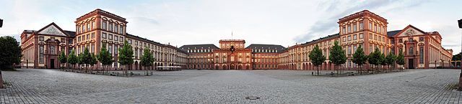

The School of Media & Communication (SMC) is proud to announce the start of a new exchange program with the School of Humanities at the University of Mannheim in Germany. The city of Mannheim is located in the southeastern portion of the country at the confluence of the Rheine and Neckar Rivers, roughly 70 km south of Frankfurt in the state of Baden-Wurttemberg. The university was first established as the “Commercial College” (or Business School) in 1907, and developed schools of law, humanities, and social sciences in subsequent years; the university has grown during that time from 3150 students to 12,000 today. Such expansion led to the state of Baden-Wurttemberg renaming the college “University of Mannheim” in 1967. The university is currently housed in Mannheim Palace, which is the second largest baroque palace in Europe (second to Versailles in Paris). Students take courses and engage in activities within and throughout the palace during their time at the university. Students should apply for this exchange program by Oct. 1. Decisions about applications will be made shortly thereafter.

Studying at the University of Mannheim
In recent years, the university has sought to recruit students globally. For this reason, most of the professors and instructors at the university are fluent in English, and there are several courses taught at University of Mannheim entirely in English each semester. In fact, most of the Media & Communication courses taught in the School of Humanities are taught to students in English. Overall, the university is recognized as a site for excellence in education, as the School of Humanities (which houses Media & Communication) has been accredited by ACQUIN (Accreditation, Certification, and Quality Assurance Institute), and the School of Business has been accredited by AACSB, EQUIS, and AMBA.

Any undergraduate students in the three departments across the School of Media & Communication (i.e., Communication, Journalism & PR, Telecommunications) are eligible to apply for the exchange program. Other applicants from other units across BGSU will also be considered. The only requirement for applicants is that they need to have a 2.5 GPA or higher. When students return from Mannheim following their semester abroad, they may use their courses to fulfill appropriate departmental, college, or university requirements.

Living in Mannheim
Mannheim is the eighth largest city in Germany, roughly the same size as Toledo, Ohio. Throughout the city, students will encounter numerous landmarks and sites of historical significance. The palace at Mannheim, the Jesuit Church, and the baroque water tower at Freidrichsplatz are all within walking distance of one another and the university. The city center, where the university is located, is amazingly easy to learn and navigate. Known as the Quadrate (or Quadrant in English), the city center exists as a grid in which streets are not named. Instead, city blocks are labeled by number and letter coordinates, such as B5 or E7. Students should have little problem finding landmarks and exploring the city.

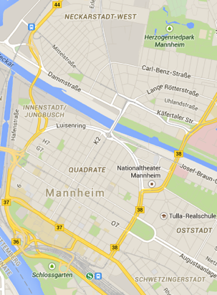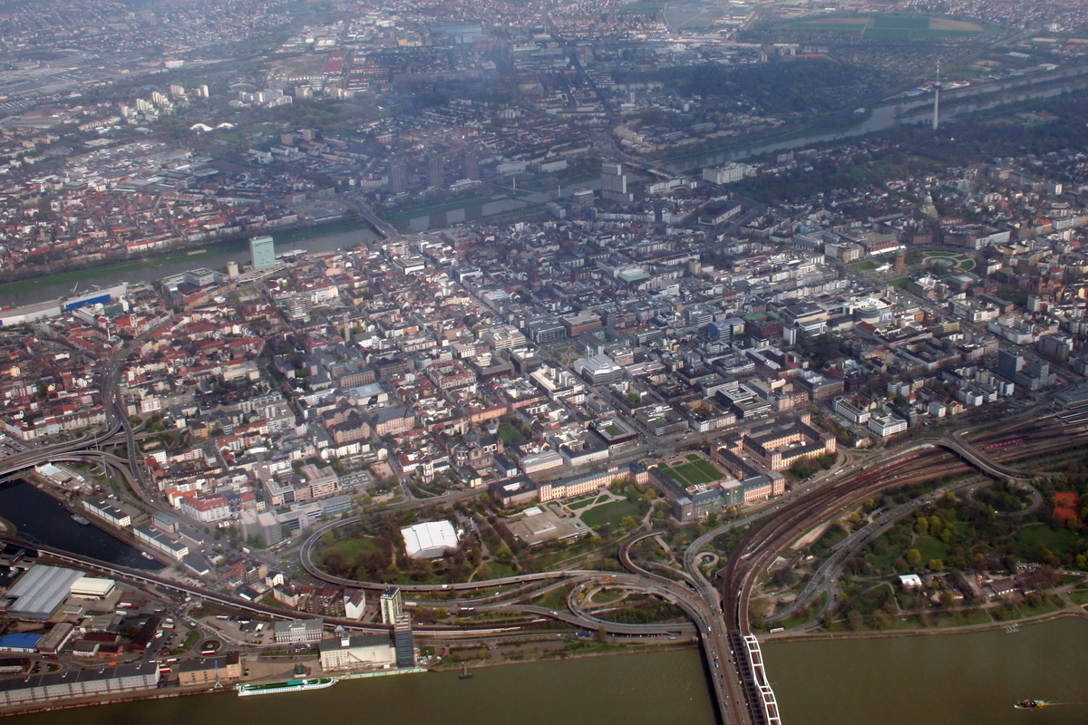

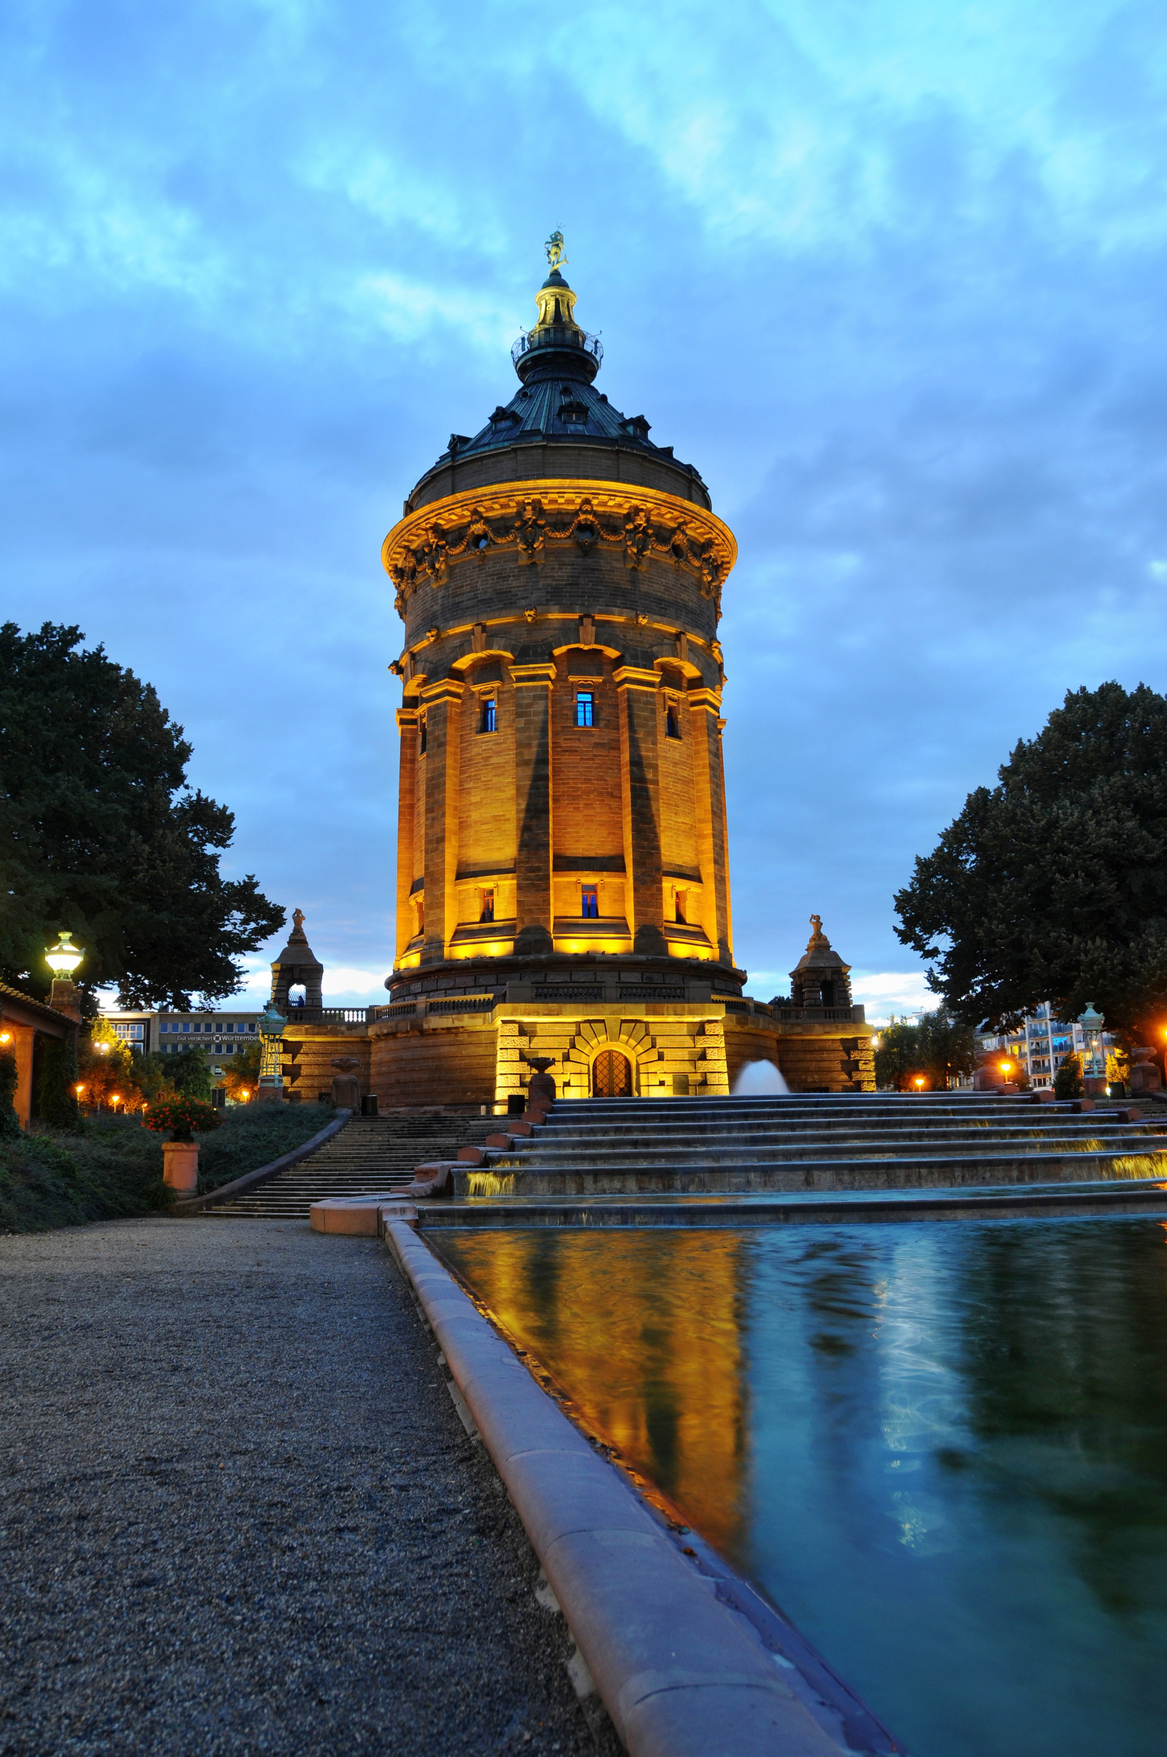
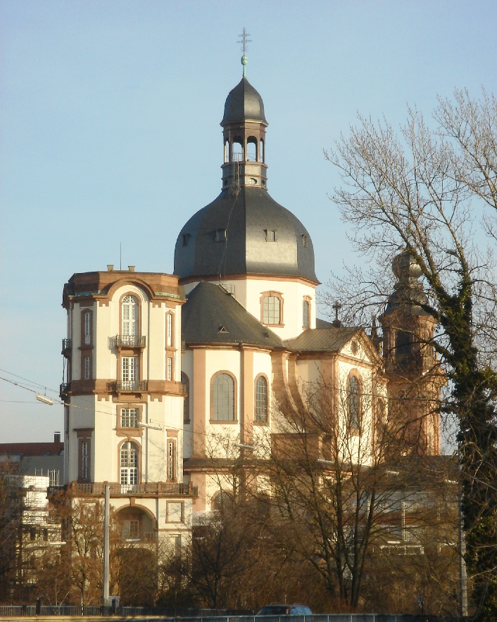

The city of Mannheim boasts an excellent public transportation system, which allows students to move about the region and explore nearby towns and cities, like Heidelberg, Heilbronn, and Stuttgart. The Verkehrsverbund Rhein-Neckar (VRN) train network interconnects neighborhoods, villages, and towns throughout the immediate region around Mannheim, while the Deutche Bahn (DB) train system connects the region to the rest of Germany. Students should find VRN and regional DB transportation to be quite affordable, creating numerous opportunities for travel and exploration.

The International Office provides a limited number of dorm rooms for international exchange students each semester. Students may also work with the International Office to find private rooms and housing in the city of Mannheim. Students will find that any housing accommodations will be in safe neighborhoods, with access to services, restaurants, and medical facilities. The sooner that students are accepted for the exchange program, the sooner they may begin working with the International Office to gain access to dorms or private housing in the immediate area. For this reason, it is imperative that students apply by the Oct. 1 deadline.

Further Information
Please feel free to contact Dr. Joshua Atkinson (jatkins@bgsu.edu) or Dr. Sandra Faulkner (sandraf@bgsu.edu) in the Department of Communication if you have any questions about the university or life in Mannheim. Both spent a semester there in the fall of 2014, and are quite knowledgeable about the university and the region. You may also check the following links below for more information:

University of Mannheim website (English):
https://www.uni-mannheim.de/1/english/

University of Mannheim International Office website:
http://www.uni-mannheim.de/io/english/incoming_exchange_students/index.html

BGSU exchange info and application: https://bgsu.studioabroad.com/index.cfm?FuseAction=Programs.ViewProgram&Program_ID=10676

