Qualtrics Help Information
Qualtrics users seeking support (e.g., live chat, phone call, or email) need to log into the Qualtrics Support Portal following the steps below.
- Log into Qualtrics using the BGSU single sign on link: http://bgsu.qualtrics.com/

- Within Qualtrics, click on the question mark icon:
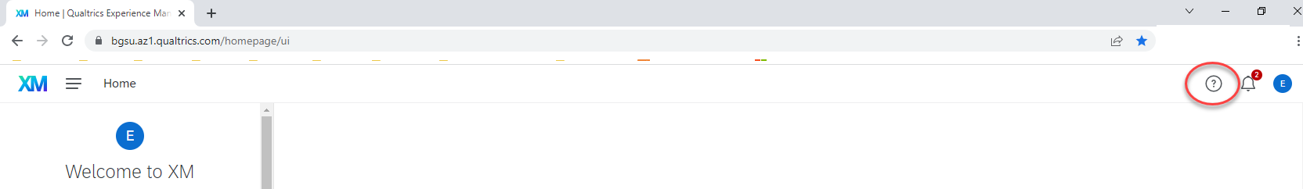
- Click on “Contact Support”

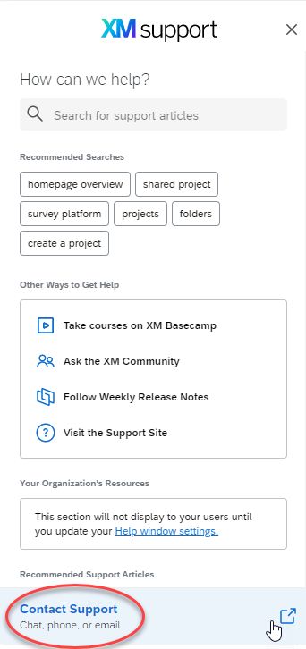

- Click on Bowling Green State University
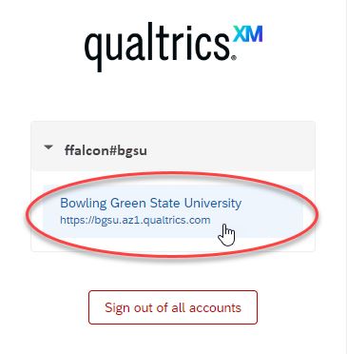

- Click on the “Get Technical Support” button.
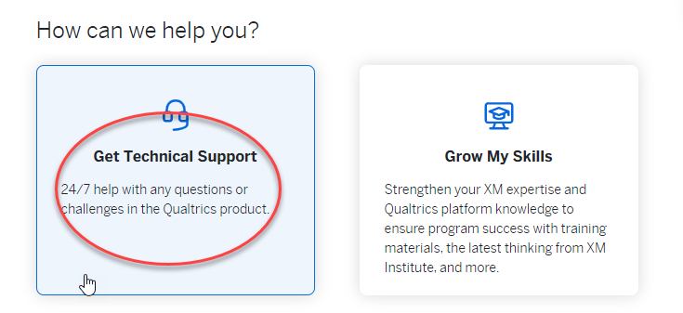

- Select “Survey Platform” then click on the support type of interest (live chat, phone call, or email).
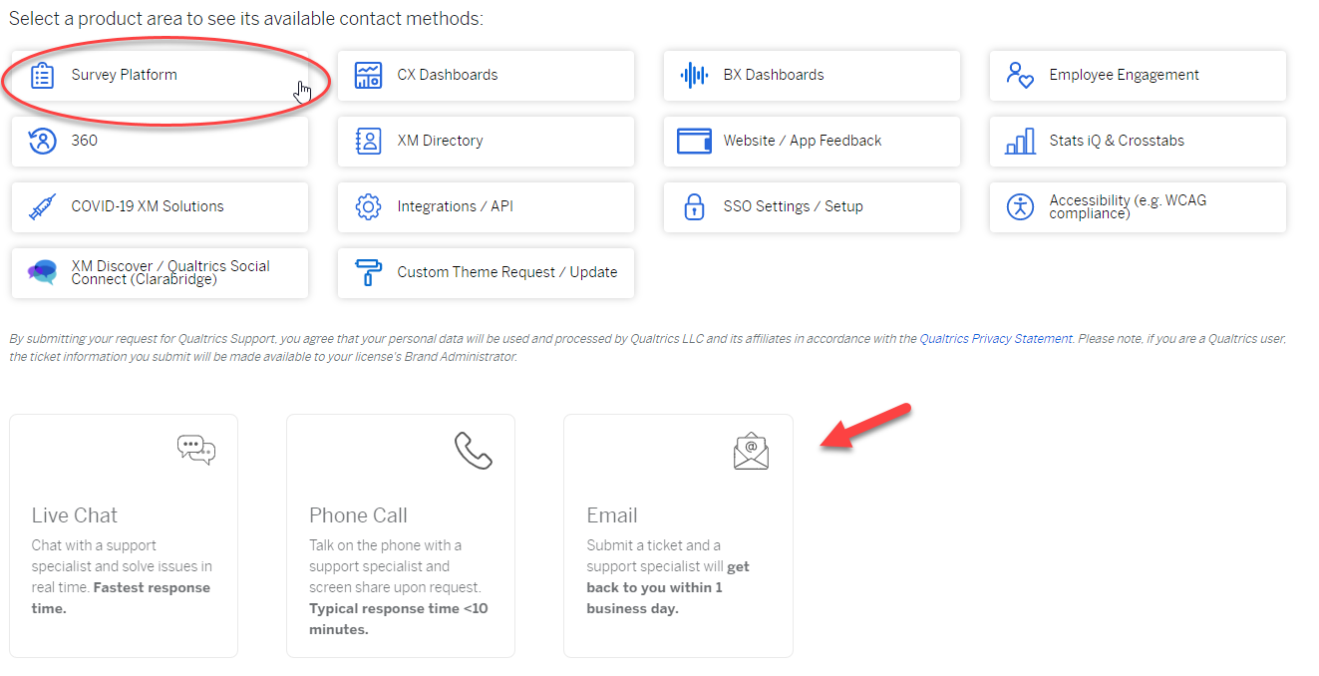

- When communicating with Qualtrics be as specific as possible with your questions and provide the name of your survey project if applicable.

